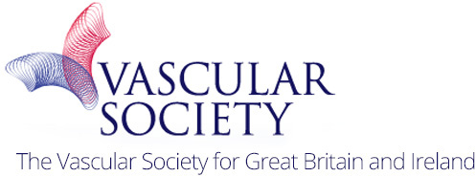

An Introduction to Vascular Surgery Skills Course

VSAGM

November 2017

Date: Wednesday 22nd November 2017
Afternoon 14:00 – 17:00
Cost £20
Venue: Manchester Central

We are delighted to announce the first annual “Introduction to Vascular Surgery” course. This will be a whole afternoon of hands-on exposure to Vascular Surgery. The delegates will rotate around surgical skills stations where they will be taught:
EVAR simulation & Angioplasty  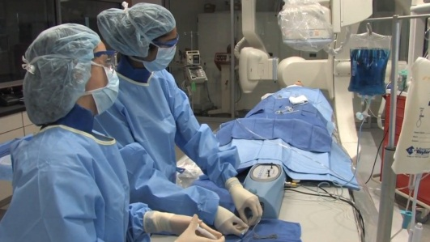 | Vascular Anastomosis  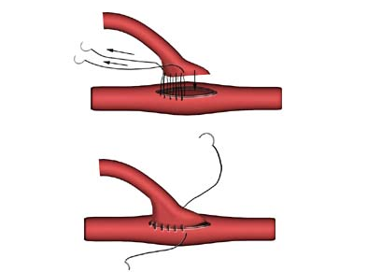
Arteriotomy and closure  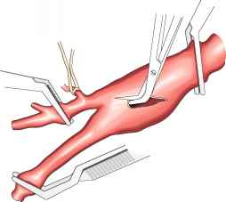 | Patch repair

There will be free registration to the Vascular Society AGM for all entrants who apply for the Student essay competition.

For further details please contact
http://www.rouleauxclub.com/forms/register/
https://www.vascularsociety.org.uk/asm/tickets_fees.aspx

