Spring 2018 Newsletter
Welcome to the Spring newsletter. A lot has happened in the last few months and I am keen to keep you all informed about the activities of your council. I do not like to bombard you with too many e-mails so I have asked the Committee chairs to highlight activities in their area of responsibility but I would encourage you to visit the website for regular updates and resources.
We hope you find this Spring 2018 newsletter informative. If there are issues you would like to know more about from the Society please let us know and we can work on including these in future newsletters and other communications.

Sophie Renton – Honorary Secretary

President’s report - Kevin Varty
This year’s annual scientific meeting will be in Glasgow at the Scottish Event Campus (SEC) November 28th-30th. Save the date. Glasgow is well connected, the SEC campus has more hotels and links to the city centre now, so it makes for a fantastic venue. The headline theme for this year will be “Evidence for Excellence”. What evidence is there to support our current practice? As always, we will aim to cover as much as we can in the time available using feedback from last year on the topics you wanted in the programme. I hope this generates the discussion and interaction which traditionally has been a feature of the Vascular Society meeting.
There is much work in progress for the VS council at present as outlined in the committee reports in this newsletter. All this aims to improve and develop vascular surgical practice now and going forward. I am mindful that the backdrop to this currently is unprecedented pressures in the NHS making delivery of service a major challenge. Whilst we need to do the best we can in the current circumstances you will all ask what is being done to change things? This was discussed amongst all surgical specialty associations and the 4 royal colleges at the January Forum meeting. The forum provides an influential united surgical “voice” that we will use to call for change and highlight the adverse effects the current capacity shortages are having on surgical practice.

Bullying, Harassment and Undermining – Rob Fisher
Following the highly successful session on Bullying, Harassment and Undermining at the VS ASM in November, the working group has met to review the Vascular Society’s position. The latest results from a new consultant’s survey corroborates the findings of the trainee’s survey with 50% having been exposed to such behaviour. Some examples were given and institutions named, however no individual or patient was deemed at immediate risk. The institutions will be alerted to the fact that bullying behaviour has been identified by their trainees, with advice regarding resources for improving behaviour in the workplace and appropriate accreditation for trainers e.g. RCS Ed online bullying module: ;
https://www.rcsed.ac.uk/professional-support-development-resources/bullying-and-undermining-campaign/what-can-you-do
RCS Eng TrACE course:
https://www.rcseng.ac.uk/education-and-exams/courses/search/training-and-assessment-in-the-clinical-environment-trace/

In addition there is clear advice offered in a statement to be posted on the VS website that includes the process of escalation for anyone that is concerned about bullying. This includes communication with Clinical and Educational Supervisors, the trust and deanery representatives, the SAC and ultimately Professional Affairs and GMC. In addition, there are Freedom to Speak up Guardians in each trust (www.cqc.org.uk/national-guardians-office/content/national-guardians-office) and a Rouleaux Trainee representative (hannahtravers@doctors.org.uk) who can confidentially discuss any concerns an individual may have.
Representatives from the working group attended a recent conference on Tackling Bullying in the NHS, where inspirational presentations on the deleterious effect of incivility on team performance and the importance of role-modelling were given. These speakers have been invited to attend the ASM in Glasgow and we are confident that the Rouleaux club will produce another strong session on this important matter. Discussion with GMC representative at the conference emphasised their stance that individuals and institutions should strive to resolve most episodes of bullying and undermining at a local or regional level. A useful diagram to summarise this is the Vanderbilt Centre for Patient and Professional Advocacy:

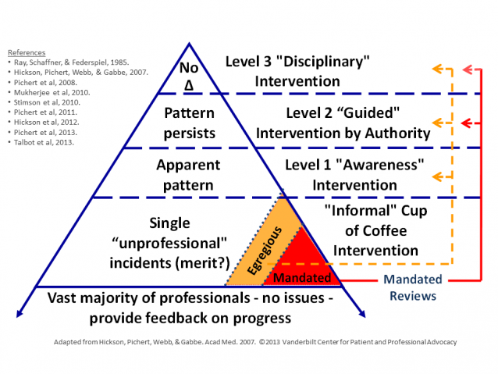
The Improving Surgical Training Project and Run-through training in Vascular Surgery – Mark McCarthy

Currently Vascular Surgery recruits its trainees at ST3 level but from August 2019 there will be 10-12 ST1 vascular surgical trainees commencing a run through pilot training programme in line with General Surgery’s IST project. The recruitment process will be commencing in

early 2019 and will be part of the standard core surgical training application process. It is envisaged that trainees will do a year of general surgery training as part of the IST project followed by at least 6 months of Vascular Surgery with no general surgery on-call. They can then do another 6 months of either vascular surgery, ITU, cardiothoracic surgery, general surgery or plastics. They will also have be part of the ASPIRE programme and will have access to the use of endovascular and open surgical simulators. Ongoing planning is underway with the IST project team and calls for interested Deaneries and Schools of Surgery will be released shortly.

Education Committee report - Prof Ian Chetter, Chair Education Committee
The ASPIRE programme goes from strength to strength and receives support from HEE.

The Annual Speciality Registrar Education (ASPIRE) programme continues to develop rapidly. The inaugural ASPIRE 7 – preparation for the FRCS (Vasc) course took place in the Hull Institute for Learning and Simulation (HILS) on Friday 9th & Saturday 10th February 2018. The programme included both formative and summative mock FRCS (Vasc) examinations, academic paper reviews in journal club environment, and a series of short small group tutorials on trainee selected difficult topics. The overall aim was to provide trainees with experience of the FRCS(Vasc) situation, pressure and content. Trainees’ performance was scored throughout the course and the “Top Gun” was Mr Tom Wallace, HEE Yorkshire and Humber
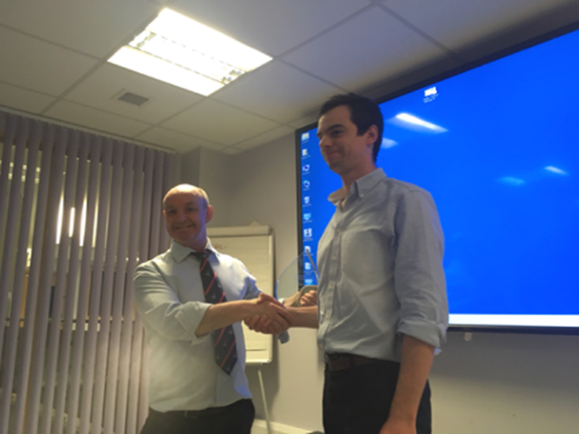

Feedback was excellent and we plan to run ASPIRE 7 again in February 2019. I would personally like to thank the faculty (Karim El Sakka, Rachel Barnes, Jagjeeth Naik, Jon Ghosh, George Smith, Paul Renwick, Brian Johnson, Nick Shaper, Paul Bevis, Simon Kreckler, Seamus Harrison, Patrick Lintott, Andy Garnham, Neil Hopper, Hosaam Nasr, Chris Imray) without whom the course would not be possible.
Funding to help support the ASPIRE programme was obtained through application in open competition by the education committee from Health Education England. This funding will help support the cadaveric ASPIRE 4 and 6 courses convened by Patrick Coughlin in Cambridge in May 2018. The established ASPIRE 5 is scheduled for Thursday 5th – Saturday 7th April 2018 and ASPIRE 3 for Friday 28th – Sunday 30th September 2018
Finally ASPIRE 8 – preparation for consultant practice is scheduled for early 2019 convened by Mr Keith Jones.

Report from the Audit and QI Committee – Jon Boyle
As the new chair of the Audit and QI Committee, I recognise that there are a number of challenges facing the committee in the coming months. A number of the recommendations in the recently published GIRFT report specifically relate to data quality and the NVR. We will be working with GIRFT to drive improvements in both case ascertainment and data quality. Whilst data for AAA and carotid procedures is good, there is still plenty of room for improvement in case ascertainment for lower limb amputation, which remains only just over 50% and lower limb angioplasty, with three quarters of cases not being entered.
GIRFT is also keen to drive improvements to the delays from symptom to surgery for carotid endarterectomy and from AAA threshold to surgery.
GIRFT has also identified the need for a Quality Improvement Framework (QIF) for lower limb ischaemia. This important initiative will be taken forward by the Vascular Society Council.
In summary the priorities for my tenure are
- Improving data ascertainment and quality
- Driving improvements in the timelines to treatment for carotid and AAA surgery
- Reporting longer term outcome data for in particular AAA patients
- Developing a QIF for lower limb ischaemia
- Improving and modifying NVR datasets and investigate the possibility of recording unique device identifiers (UDIs) within the NVR.
Finally I would like to remind all members the deadline for submission for 2017 cases is 16th March 2018.
The full report can be accessed on the website.

The Circulation Foundation Report – Mike Jenkins
The Circulation Foundation is now on a more stable financial footing thanks to the generosity of members, fund raisers and major donors. As such, we have joined forces with the Royal College of Surgeons of England to offer two Research Fellowships which are currently out to advert. In addition, there will be further grants available which will be open to applications from members of the VS, SVN and SVT. These will be advertised on the website later in the year.
To be able to direct patients to reliable information on line, please take the opportunity of adding the CF website details www.circulationfoundation.org.uk to your correspondence (which is now copied to all patients and GPs), either as a permanent footer or in the body of the letter. This will allow patients access to a digital version of the information leaflets and allow them to get more information about CF fundraising events and opportunities to join in
or donate.
A Golf Pro-Am Tournament is being held at Hart Common Golf Course and monies raised are going to the Circulation Foundation. If interested in either participating or even sponsoring the event please look at https://boltongolffestival.co.uk/
Adding the CF logo and text donation number (see below) to your e mail can also be helpful

to spread the word.
Text CIRC10 £5 to 70070 to donate to the Circulation Foundation and make a difference today
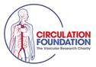

Research Committee 2018 - Professor Chris Imray
Over the last three years the VS Research Committee has made a strategic decision to explore diverse funding streams (such as NIHR) and to broaden vascular research involvement.
We hope to increase the number of trials, the numbers of patients recruited to trials, and to increase involvement of patients, trainees and allied professionals.
A key early step was the appointment of a Royal College of Surgeons Surgical Specialty Lead in Vascular Surgery, Prof. Ian Chetter who started work in this post in January 2016. An early step was the setting up of a Delphi process to ask the VS membership the research questions that they feel are important. The next steps will include setting up special interest groups. A James Lind Alliance approach to priority setting will then take place with the aim of subsequently putting in bids for NIHR or other related charity bids for external funding.
In addition, we are delighted to announce that the Royal College of Surgeons of England have agreed to match fund Circulation Foundation monies for scholarships specifically aimed at trainees. The Circulation Foundation has match funded the Garfield Weston and the James Tudor charities to fund a pilot multi-centre study looking at barriers to participation in claudication classes.
The full report can be accessed on the website.

Rouleaux Club 2017 review
Iain Roy, President Rouleaux Club, ST5 Vascular Surgery, Northwest (Mersey) Deanery
Olivia McBride, Vice-President Rouleaux Club, ST6 Vascular Surgery, Scotland & The Defence Deanery

The Rouleaux Club (RC) has had a busy and productive year during 2017. Our membership has continued to grow, following an update to our membership systems. We have also seen increased engagement with medical students, foundation doctors and core surgical trainees. There has been a drive to encourage and promote vascular surgery at a time when overall numbers of applicants for surgical specialties are falling. The success of the medical student essay competition, the introduction to vascular surgery courses and the national vascular training day (NVTD) have stimulated interest as well as supported those already in training. Our work to ensure the highest standards of training are delivered in a fair and equal manner across the UK continues through the use of surveys and we are grateful to our membership for their contribution. A major re-write of the vascular logbook was completed

this year by RC committee members, which will better record operative experience, in training and beyond.
Our major project this year has been identifying and responding undermining, bullying and harassment within vascular surgery. Working with the Vascular Society we have developed an action plan to confine these negative behaviours to the past while supporting our membership, create a balanced and supportive environment to train within and ensures the highest standards of patient care.
Finally, we must be reminded of our raison d’etre; our patients. Members of the RC committee have been avidly raising money for the Circulation Foundation over the past year and running seems to be the method of choice!
The work of the RC would not be possible without the support and recognition of the Vascular Society, the British Society of Endovascular Therapy (BSET) and of course our membership.

Introduction to Vascular Surgery for medical Students, foundation doctors and core surgical trainees considering a career in Vascular Surgery at the Charing Cross Symposium – Thursday 26th April – London Olympia Grand Hall
This is a new initiative to attract the next generation of Vascular Surgeons. The Vascular Society and the Rouleaux Club are excited to be invited to run this course at Charing Cross Symposium. As well as hands on training in vascular anastomosis, trainees will be able to attend demonstrations, use simulators and watch live streamed cases. Do please advertise this course in your Medical Schools and Foundation Schools, as well as promoting it to your Core Surgical Trainees. Interested candidates should contact sophie.renton@nhs.net. Places are limited and will be offered on a first come first serve basis. Further details can be found in the news section of the website here: https://www.vascularsociety.org.uk/professionals/news/56/an_introduction_to_vascular_surgery_course

UEMS and the European Registry of Vascular Surgery
This is a voluntary registry of training facilities in Europe. Units are invited to register if they have spare training capacity and are interested in welcoming overseas trainees to their units. https://uemsvascular.com/

Confederation of British Surgeons - FSSA
We have been asked to bring this initiative to your attention
The aim of the Confederation of British Surgery (CBS) as a Professional Association would be to act as a ‘Trade Union’ for surgeons and to look after their professional and employment interests irrespective of Surgical Royal College or Surgical Specialty Association affiliation. As such, CBS would be able to involve itself in matters relating to terms and conditions of service, contracts of employment, litigation, insurance and other matters from which the Surgical Royal Colleges and the numerous Surgical Specialty Associations are effectively excluded on the basis of their charitable status and the ‘public benefit’ concept which this entails: https://fssa.org.uk/confederation-of-british-surgeons

