





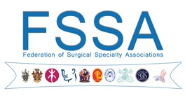 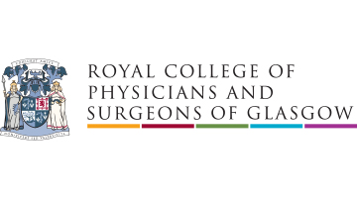

**Association of Surgeons of Great Britain and Ireland, Royal College of Surgeons of England, Royal College of Surgeons of Edinburgh, Royal College of Physicians and Surgeons of Glasgow and Federation of Surgical Specialty Associations Position Statement on the Legal Aspects of “Medical Manslaughter”**

The Association of Surgeons of Great Britain & Ireland, the Royal College of Surgeons of England, the Royal College of Surgeons of Edinburgh, the Royal College of Physicians and Surgeons of Glasgow and the Federation of Surgical Specialty Associations view with great concern the recent and highly publicised instances of the criminal prosecution, for gross negligence manslaughter, of individual medical practitioners and other health professionals, notably with regard to Drs. Sellu and Rudling and the optometrist, Ms. Rose.

That concern has been heightened by the successful GMC proceedings to overturn the decision of the MPTS not to erase Dr. Bawa-Garba from the Register (GMC v Bawa-Garba[2018] EWHC 76) after her conviction (R v. Bawa-Garba 2015). We note that Dr. Bawa-Garba has now been granted leave to appeal, notably with regard to R v. Bawa-Garba [2015].

The decision whether to prosecute such cases requires the Crown Prosecution Service to conclude for each case not only that there is a realistic prospect of conviction, but also (and crucially), that do so is in the public interest. We are concerned that the prosecution of individual medical practitioners, in the context of systematic failings which result in tragic and avoidable deaths, not only fails to adequately address the public interest, but may have precisely the opposite effect.

Healthcare professionals, by the very nature of their occupation, must treat, as a matter of routine, members of society whose healthcare needs put them at potential or actual risk of death and life-altering morbidity. This is especially true in the case of surgeons, whose actions routinely and deliberately expose their patients to risk of harm and threat to life, in order to save or prolong life and to improve wellbeing. Modern medicine and surgery has led to the evolution of integrated systems of organizational care, so this care is almost never delivered by an individual in isolation, but as part of a multidisciplinary team, composed of members with mutually complementary roles and responsibilities, and within corporate structures responsible for the provision of training, supervision, audit and clinical governance.

Surgeons support the need for a culture of openness and transparency, set out in their statutory duty and specified in the GMC professional duty of candour (GMC 2015), not only for the benefit of those immediately affected when an avoidable death occurs, but also as the basis for establishing an appropriate environment for reflective practice, learning from mistakes and identifying shortfalls in key resources which may lead or contribute to adverse events. Other industries, notably the aviation industry, have long since recognised these principles, resulting in considerable improvements in safety.

We believe that the current application of criminal law to deaths resulting from medical errors cannot always be in the public interest if these principles are to be upheld. On the contrary, we note with dismay that recent cases, such as R v. Sellu and R v. Bawa-Garba are leading to the creation of a culture of fear, because of the threat of criminal charges and imprisonment, among a workforce already demonstrably struggling to cope with significant resource shortfalls. The confidence of healthcare professionals in their ability to discharge their duties without exposing themselves to risk of criminal prosecution, particularly when working in circumstances in which systematic deficiencies may result in suboptimal care appears to have been substantially undermined, not only by a seeming increase in the willingness of the police to investigate, but also for the CPS to prosecute, individuals in cases where patients have died as a result of alleged clinical negligence.

While the apparent difficulties in applying the Corporate Manslaughter Act of 2007 (at all, and to healthcare in particular) have been recognised, it seems unreasonable and unlikely to serve the public interest if the reluctance to do so results instead in the “scapegoating” of individual healthcare professionals, simply because they are the most easily identifiable and immediately accountable elements of a failing organization. We believe this is not only unjust but fails to support the ready identification and correction of resource shortfalls when they cause or contribute significantly to avoidable hospital mortality.

Such convictions have demonstrably failed to improve patient safety, indicated for example, by the further cases of accidental intrathecal injection of Vincristine reported to have occurred despite the landmark case gross negligence manslaughter case of R-v-Prentice; R v. Sullman 1994. Furthermore, because the existing criminal law serves only to punish individuals whose actions (or omissions) result in death, it does not address cases of serious medical malpractice which results in adverse outcomes short of death, or those where an intervening cause may break the chain of causation, making it difficult or impossible to establish that relevant actions or omissions were responsible. There is no lesser included offence.

The application of gross negligence manslaughter law has also raised concerns by academic lawyers (e.g. Brazier and Alghrani 2009, Quick 2017), notably with regard to the circularity of the definition of “gross negligence”, and the reliance on the jury to be able “supremely” to determine whether a defendant’s conduct was bad **in all of the circumstances** (R v. Adomako 1995). This, in our view, potentially puts jurors under inordinate pressure to understand the intricate consequences of a series of healthcare failings that may leave a single member of a healthcare team inappropriately held accountable for systematic failings which result in death.

In summary, we believe that it is inappropriate to continue to apply the current criminal law to individual healthcare practitioners working in circumstances in which it may not be possible for them to provide adequate care for patients and we strongly support the views of Sir Ian Kennedy QC (BMJ 2018;360:k1376) that doing so simply causes problems, rather than provides solutions, when medical errors under those circumstances result in death.

In the event that it is believed necessary to have recourse to the criminal law, in order to address circumstances in which healthcare professionals, in the routine exercise of their occupation, may be at risk of prosecution for gross negligence manslaughter, we believe that the provisions suggested by Brazier and Alghrani (2009) and the subject of a subsequent essay to the Bar Council, should be considered. They have suggested (*inter alia*) that for negligence to be “gross”, it must be proven that the alleged negligence fell short of responsible professional practice so as to engage liability in clinical negligence, and that *either* the healthcare professional showed indifference to an obvious risk to the patient, *or* the healthcare professional was (or should have been) aware of that risk, yet exposed the patient to it for no accepted medical benefit, *unless* the health care professional can provide evidence of significant mitigating factors, such as that they were working in circumstances that substantially impaired their ability to provide adequate care for their patient, or that they lacked the experience or capacity to deliver the treatment in question.

We understand that the current terms of reference of the Williams review are limited only to the processes employed in cases of gross negligence manslaughter (within the existing law), the information provided to healthcare professionals, the means of protecting openness and transparency and the role of the healthcare regulators. We are concerned that this process is unlikely to achieve its goals unless it also addresses what appear to be significant limitations in the current law and its reliable application to all of the elements required for the effective delivery of modern healthcare.

The Association of Surgeons of Great Britain and Ireland, the Surgical Royal Colleges and Federation of Surgical Specialty Associations believe that this can only be addressed effectively by legal reform, specific to the circumstances in which hard-pressed medical practitioners routinely find themselves, in order to ensure that a culture of learning from mistakes, reflection and continuous improvement can be maintained and, where appropriate, organizations, rather than individuals, can be held to account for failings when they arise and result in avoidable death.

**References**

1. End medical manslaughter. BMJ 2018;360:k1376.

2. Brazier M, Alghrani A. Fatal medical malpractice and criminal liability. Journal of Professional Negligence (2009) 25: 51–67.

3. Quick O. Medical manslaughter- time for a re-think? Medicolegal journal 2017; 85: 173-181.

4. General Medical Council. Openness and honesty when things go wrong: the professional duty of candour. https://www.gmcuk.org/DoC_guidance_english.pdf_61618688.pdf

**Signed, 5 April 2018**

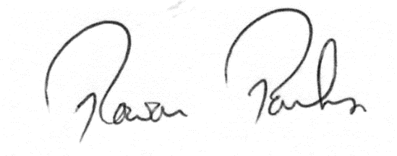

Professor Rowan Parks, President, Association of Surgeons of Great Britain & Ireland

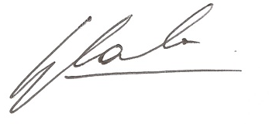

Professor Gordon L. Carlson, Chair, Medicolegal Committee, Association of Surgeons of Great Britain & Ireland



Professor Derek Alderson, PRCS England



Professor Michael Lavelle-Jones, PRCS Edinburgh

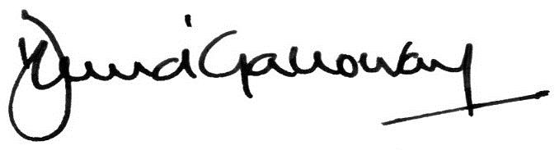

Professor David J. Galloway, PRCPS Glasgow



Mr Nigel Mercer, President, Federation of Surgical Specialty Associations